Name : Allahdad

Section : “D”

Lab:03

CMS(023-22-0056)

1. Write a Java program which program linear search. It takes user input; if the elment is found in the array it display element is found or not found. As shown in the following figure.

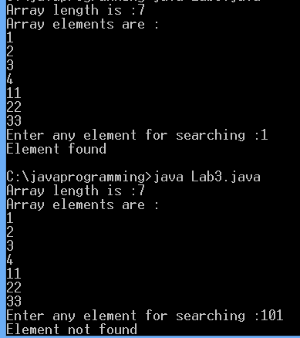

Input

import java.util.Scanner;

class Q1

{

public static void main(String args[])

{

Scanner ip=new Scanner(System.in);

System.out.println("Enter the size of array:");

int size=ip.nextInt();

int arr[]=new int[size];

System.out.println("Array elements are:");

for(int i=0;i<size;i++)

{

arr[i]=ip.nextInt();

}

System.out.println("Enter any element for seaching:");

int no=ip.nextInt();

int a=0;

for(int i=0;i<size;i++)

{

if(no==arr[i])

{

System.out.println("Number is found");

break;

}

else if(a==size-1)

{

System.out.println("Number is not found ");

}

++a;

}

}

}

Output

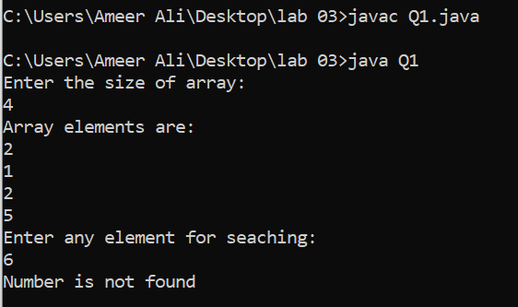

1. Write a Java program which takes user CNIC as an input without dashesh. It display CNIC with dashes. As shown below

Enter any CNIC : 4511122334459

Output: 45111-2233445-9

Input

import java.util.Scanner;

class Q2

{

public static void main(String args[])

{

Scanner ip=new Scanner(System.in);

System.out.println("Enter the CNIC number:");

char y[]=ip.next().toCharArray();

char z[]=new char[y.length+2];

for(int i=0;i<y.length+2;i++)

{

if(i<5)

{

z[i]=y[i];

}

else if(i==5)

{

z[i]='-';

}

else if (i>5&&i<=12)

{

z[i]=y[i-1];

}

else if (i==13)

{

z[i]='-';

}

else

{

z[i]=y[i-2];

}

System.out.print(z[i]);

}

}

}

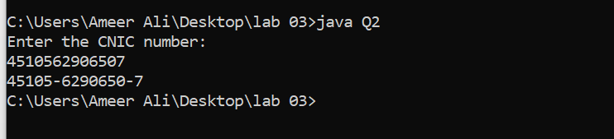

1. Write a Java program that creates an array which takes odd numbers from 1-10 and display total sum of odd numbers.

----------------------

Odd Numbers 1-10

Enter odd numebr: 1

Enter odd number : 3

Enter odd number : 5

Enter odd number : 7

Enter odd number : 9

Total Sum: 25

Input

import java.util.Scanner;

class Q3

{

public static void main(String args[])

{

System.out.println("Odd number 1-10");

Scanner ip=new Scanner(System.in);

int arr[]=new int[5];

int sum=0;

for(int i=0;i<5;i++)

{

System.out.print("Enter Odd number:");

int no=ip.nextInt();

sum=sum+no;

}

System.out.print("Total sum="+sum);

}

}

Output

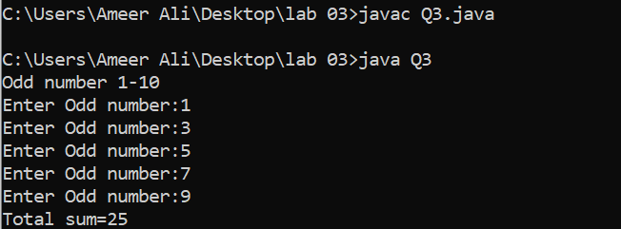

1. Writa a Java program which create an array of students marks. You are are required to calcuate the average marks of the students. Array length should be 20.

Input

import java.util.Scanner;

class Q4

{

public static void main(String args[])

{

Scanner ip=new Scanner(System.in);

System.out.println("Calculate average of how many Students:");

int size=ip.nextInt();

int smarks[]=new int[size];

int average,sum=0;

for(int i=0;i<size;i++)

{

System.out.println("Enter the marks of Student "+i);

smarks[i]=ip.nextInt();

sum+=smarks[i];

}

average=sum/size;

System.out.print("Average is "+average);

}

}

Output

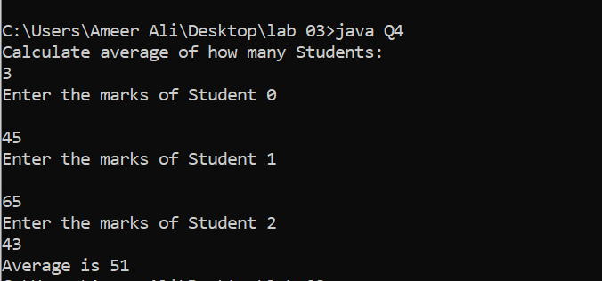

1. Write a Java program to print the elements of an array in reverse order.

Input

class Q5

{

public static void main(String args[])

{

int arr[]={1,2,3,4,5,6,7};

for(int i=0;i<7;i++)

{

System.out.print (arr[i]+" ");

}

System.out.print ("\nReverse array \n");

for(int i=7-1;i>=0;i--)

{

System.out.print (arr[i]+" ");

}

}

}

Output

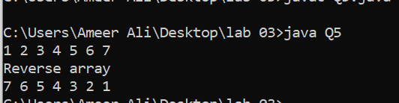

1. Write a Java program which convert degrees into radians and radians into degrees.

Input

import java.util.Scanner;

class Q6

{

public static void main(String args[])

{

Scanner ip=new Scanner(System.in);

double radian,degree;

System.out.print("First degree into radian\n");

System.out.print("Enter the value of degree: ");

degree=ip.nextDouble();

radian=(degree)\*(3.14/180);

System.out.println("\nThe radian:"+radian);

System.out.print("Second radian into degree\n");

System.out.print("Enter the value of radian\n");

radian=ip.nextDouble();

degree=(radian)\*(180/3.14);

System.out.println("\nThe Degree =:"+degree);

}

}

Output

